THE NORMADIC TRIBES OF ARABIA

The nomadic pastoralist Bedouin tribes inhabited the Arabian Peninsula before the rise of Islam around 700 CE.

LEARNING OBJECTIVES
Describe the societal structure of tribes in Arabia

KEY TAKEAWAYS

Key Points
- Nomadic Bedouin tribes dominated the Arabian Peninsula before the rise of Islam.
- Family groups called clans formed larger tribal units, which reinforced family cooperation in the difficult living conditions on the Arabian peninsula and protected its members against other tribes.
- The Bedouin tribes were nomadic pastoralists who relied on their herds of goats, sheep, and camels for meat, milk, cheese, blood, fur/wool, and other sustenance.
- The pre-Islamic Bedouins also hunted, served as bodyguards, escorted caravans, worked as mercenaries, and traded or raided to gain animals, women, gold, fabric, and other luxury items.
- Arab tribes begin to appear in the south Syrian deserts and southern Jordan around 200 CE, but spread from the central Arabian Peninsula after the rise of Islam in the 630s CE.

Key Terms
- Nabatean: an ancient Semitic people who inhabited northern Arabia and Southern Levant, ca. 37–100 CE.
- Bedouin: a predominantly desert-dwelling Arabian ethnic group traditionally divided into tribes or clans.

Pre-Islamic Arabia
Pre-Islamic Arabia refers to the Arabian Peninsula prior to the rise of Islam in the 630s.
Some of the settled communities in the Arabian Peninsula developed into distinctive civilizations. Sources for these civilizations are not extensive, and are limited to archaeological evidence, accounts written outside of Arabia, and Arab oral traditions later recorded by Islamic scholars. Among the most prominent civilizations were Thamud, which arose around 3000 BCE and lasted to about 300 CE, and Dilmun, which arose around the end of the fourth millennium and lasted to about 600 CE. Additionally, from the beginning of the first millennium BCE, Southern Arabia was the home to a number of kingdoms, such as the Sabaean kingdom, and the coastal areas of Eastern Arabia were controlled by the Iranian Parthians and Sassanians from 300 BCE.
Pre-Islamic religion in Arabia consisted of indigenous polytheistic beliefs, Ancient Arabian Christianity, Nestorian Christianity, Judaism, and Zoroastrianism. Christianity existed in the Arabian Peninsula, and was established first by the early Arab traders who heard the gospel from Peter the apostle at Jerusalem (Acts 2:11), as well as those evangelized by Paul’s ministry in Arabia (Galatians 1:17) and by St Thomas. While ancient Arabian Christianity was strong in areas of Southern Arabia, especially with Najran being an important center of Christianity, Nestorian Christianity was the dominant religion in Eastern Arabia prior to the advent of Islam.
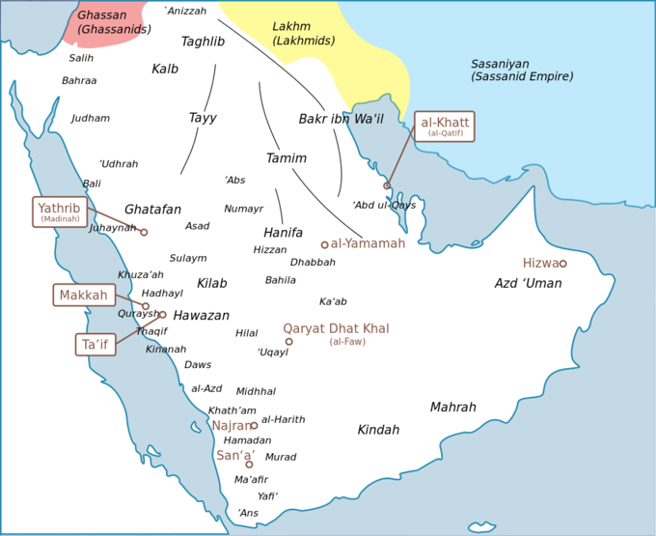
Tribes in the Arabian Peninsula c. 600 CE: Approximate locations of some of the important tribes and Empire of the Arabian Peninsula before the dawn of Islam. Family groups called clans formed larger tribal units, which reinforced family cooperation in the difficulty living conditions on the Arabian peninsula and protected its members against other tribes.

Nomadic Tribes in Pre-Islamic Arabia
One of the major cultures that dominated the Arabian Peninsula just before the rise of Islam was that of the nomadic Bedouin people. The polytheistic Bedouin clans placed heavy emphasis on kin-related groups, with each clan clustered under tribes. The immediate family shared one tent and can also be called a clan. Many of these tents and their associated familial relations comprised a tribe. Although clans were made up of family members, a tribe might take in a non-related member and give them familial status. Society was patriarchal, with inheritance through the male lines. Tribes provided a means of protection for its members; death to one clan member meant brutal retaliation.
Non-members of the tribe were viewed as outsiders or enemies. Tribes shared common ethical understandings and provided an individual with an identity. Warfare between tribes was common among the Bedouin, and warfare was given a high honor. The difficult living conditions in the Arabian Peninsula created a heavy emphasis on family cooperation, further strengthening the clan system.
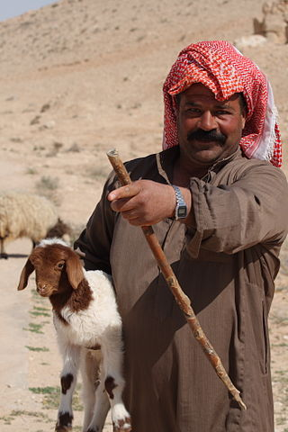
Bedouin shepherd in the Syrian desert: While most modern Bedouins have abandoned their nomadic and tribal traditions for modern urban lifestyles, they retain traditional Bedouin culture with traditional music, poetry, dances, and other cultural practices.
The Bedouin tribes in pre-Islamic Arabia were nomadic-pastoralists. Pastoralists depend on their small herds of goats, sheep, camels, horses, or other animals for meat, milk, cheese, blood, fur/wool, and other sustenance. Because of the harsh climate and the seasonal migrations required to obtain resources, the Bedouin nomadic tribes generally raised sheep, goats, and camels. Each member of the family had a specific role in taking care of the animals, from guarding the herd to making cheese from milk. The nomads also hunted, served as bodyguards, escorted caravans, and worked as mercenaries. Some tribes traded with towns in order to gain goods, while others raided other tribes for animals, women, gold, fabric, and other luxury items.
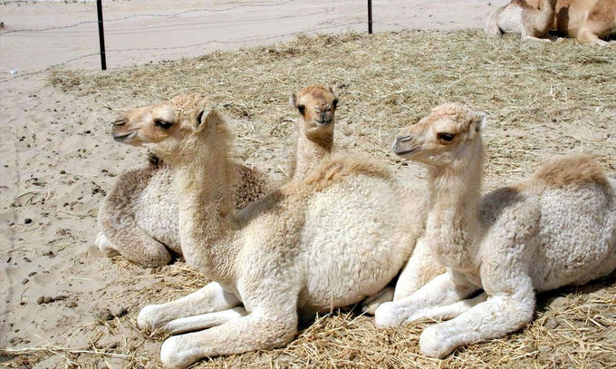
Bedouin tribes raised camels as part of their nomadic-pastoralist lifestyle: Tribes migrated seasonally to reach resources for their herds of sheep, goats, and camels. Each member of the family had a specific role in taking care of the animals, from guarding the herd to making cheese from milk.

Origin of Jewish and Other Tribes
The first mention of Jews in the areas of modern-day Saudi Arabia dates back, by some accounts, to the time of the First Temple. Immigration to the Arabian Peninsula began in earnest in the 2nd century CE, and by the 6th and 7th centuries there was a considerable Jewish population in Hejaz, mostly in and around Medina. This was partly because of the embrace of Judaism by leaders such as Abu Karib Asad and Dhu Nuwas, who was very aggressive about converting his subjects to Judaism, and who persecuted Christians in his kingdom as a reaction to Christian persecution of Jews there by the local Christians. Before the rise of Islam, there were three main Jewish tribes in the city of Medina: the Banu Nadir, the Banu Qainuqa, and the Banu Qurayza. Arab tribes, most notably the Ghassanids and Lakhmids, began to appear in the south Syrian deserts and southern Jordan from the mid-3rd century CE, during the mid to later stages of the Roman Empire and Sassanid Empire. The Nabatean civilization in Jordan was an Aramaic-speaking ethnic mix of Canaanites, Arameans, and Arabs. According to tradition, the Saudi Bedouin are descendants of two groups. One group, the Yemenis, settled in southwestern Arabia, in the mountains of Yemen, and claimed they descended from a semi-legendary ancestral figure, Qahtan (or Joktan). The second group, the Qaysis, settled in north-central Arabia and claimed they were descendants of the Biblical Ishmael.

Arabian Cities
Cities like Mecca and Medina acted as important centers of trade and religion in pre-Islamic Arabia.

LEARNING OBJECTIVES
Examine the historical significance of Mecca and Medina

KEY TAKEAWAYS

Key Points
- As sea trade routes became more dangerous, several tribes built the Arabian city of Mecca into a center of trade to direct more secure overland caravan routes.
- Once a year, the nomadic tribes would declare a truce and converge upon Mecca in a pilgrimage to pay homage to their idols at the Kaaba and drink from the Zamzam Well.
- The oasis city of Yathrib, also known as Medina, was ruled by several Jewish tribes until Arab tribes gained political power around 400 CE.

Key Terms
- Ishmael: A figure in the Hebrew Bible and the Qur’an, and Abraham’s first son according to Jews, Christians, and Muslims. He was born of Abraham’s marriage to Sarah’s handmaiden Hagar.
- Zamzam Well: A well located in the city of Mecca that, according to Islamic belief, is a miraculously generated source of water from God.
- Kaaba: A sacred building in the city of Mecca that housed the tribal idols until the rise of Islam in 7th century, when it became the center of Islam’s most sacred mosque.
Although the majority of pre-Islamic Arabia was nomadic, there were several important cities that came into being as centers of trade and religion, such as Mecca, Medina (Yathrib), Karbala, and Damascus. The most important of these cities was Mecca, which was an important center of trade in the area, as well as the location of the Kaaba (or Ka’ba), one of the most revered shrines in polytheistic Arabia. After the rise of Islam, the Kaaba became the most sacred place in Islam.
Islamic tradition attributes the beginning of Mecca to Ishmael ‘s descendants. Many Muslims point to the Old Testament chapter Psalm 84:3–6 and a mention of a pilgrimage at the Valley of Baca, which is interpreted as a reference to Mecca as Bakkah in Qur’an Surah 3:96. The Greek historian Diodorus Siculus, who lived between 60 BCE and 30 BCE, wrote about the isolated region of Arabia in his work Bibliotheca historica, describing a holy shrine that Muslims see as Kaaba at Mecca: “And a temple has been set up there, which is very holy and exceedingly revered by all Arabians.” Sometime in the 5th century, the Kaaba was a place to worship the deities of Arabia’s pagan tribes. Mecca’s most important pagan deity was Hubal, whose idol had been placed there by the ruling Quraysh tribe and remained until the 7th century.

The City of Mecca
In the 5th century, the Quraysh tribes took control of Mecca and became skilled merchants and traders. In the 6th century, they joined the lucrative spice trade, since battles in other parts of the world were causing traders to divert from the dangerous sea routes to the more secure overland routes. The Byzantine Empire had previously controlled the Red Sea, but piracy had been increasing. Another previous route, which ran through the Persian Gulf via the Tigris and Euphrates rivers, was also threatened by exploitations from the Sassanid Empire, and disrupted by the Lakhmids, the Ghassanids, and the Roman–Persian Wars.
Mecca’s prominence as a trading center eventually surpassed the cities of Petra and Palmyra. Historical accounts also provide some indication that goods from other continents may also have flowed through Mecca. Camel caravans, said to have first been used by Muhammad ‘s great-grandfather, were a major part of Mecca’s bustling economy. Alliances were struck between the merchants in Mecca and the local nomadic tribes, who would bring goods—leather, livestock, and metals mined in the local mountains—to Mecca to be loaded on the caravans and carried to cities in Syria and Iraq. Historical accounts provide some indication that goods from other continents may also have flowed through Mecca. Goods from Africa and the Far East passed through en route to Syria. The Meccans signed treaties with both the Byzantines and the Bedouins to negotiate safe passages for caravans and give them water and pasture rights. Mecca became the center of a loose confederation of client tribes, which included those of the Banu Tamim. Other regional powers such as the Abyssinian, Ghassan, and Lakhm were in decline, leaving Meccan trade to be the primary binding force in Arabia in the late 6th century.
The harsh conditions and terrain of the Arabian peninsula meant a near-constant state of conflict between the local tribes, but once a year they would declare a truce and converge upon Mecca in a pilgrimage. Up to the 7th century, this journey was undertaken by the pagan Arabs to pay homage to their shrine and drink from the Zamzam Well. However, it was also the time each year when disputes would be arbitrated, debts would be resolved, and trading would occur at Meccan fairs. These annual events gave the tribes a sense of common identity and made Mecca an important focus for the peninsula.
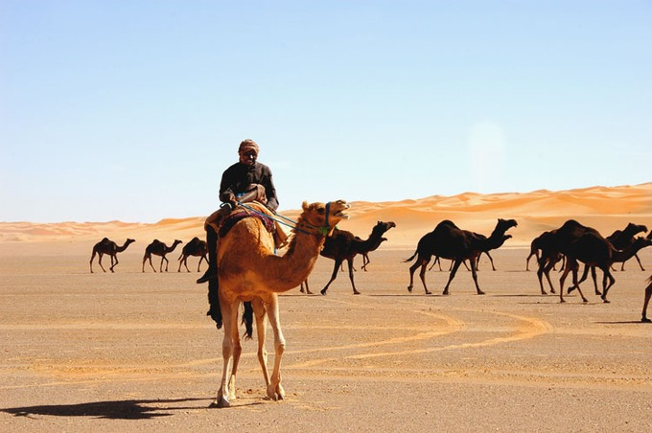
A modern-day caravan crossing the Arabian Peninsula: As sea trade routes became more dangerous, several tribes built the Arabian city of Mecca into a center of trade to direct more secure overland caravan routes.

The City of Medina (Yathrib)
Although the city of Medina did not have any great distinction until the introduction of Islam, it has always held an important place in trade and agriculture because of its location in a fertile region of the Hejaz. The city was able to maintain decent amounts of food and water, and therefore was an important pit stop for trade caravans traveling along the Red Sea. This was especially important given the merchant culture of Arabia. Along with the port of Jidda, Medina and Mecca thrived through years of pilgrimage.
During the pre-Islamic period up until 622 CE, Medina was known as Yathrib, an oasis city. Yathrib was dominated by Jewish tribes until around 400 CE, when several Arab tribes gained political power. Medina is celebrated for containing the mosque of Muhammad. Medina is 210 miles (340 km) north of Mecca and about 120 miles (190 km) from the Red Sea coast. It is situated in the most fertile part of the Hejaz territory, where the streams of the vicinity converge. An immense plain extends to the south; in every direction the view is bounded by hills and mountains.
In 622 CE, Muhammad and around 70 Meccan Muhajirun believers left Mecca for sanctuary in Yathrib, an event that transformed the religious and political landscape of the city completely. The longstanding enmity between the Aus and Khazraj tribes was dampened as many tribe members, and some local Jews, embraced Islam. Muhammad, linked to the Khazraj through his great-grandmother, was agreed on as civic leader.
The Muslim converts native to Yathrib—whether pagan Arab or Jewish—were called Ansar (“the Patrons” or “the Helpers”). According to Ibn Ishaq, the local pagan Arab tribes, the Muslim Muhajirun from Mecca, the local Muslims (Ansar), and the Jews of the area signed an agreement, the Constitution of Medina, which committed all parties to mutual cooperation under the leadership of Muhammad. The nature of this document as recorded by Ibn Ishaq and transmitted by Ibn Hisham is the subject of dispute among modern Western historians. Many maintain that this “treaty” is possibly a collage of different agreements, oral rather than written, of different dates, and that it is not clear when they were made. Other scholars, however, both Western and Muslim, argue that the text of the agreement—whether it was originally a single document or several—is possibly one of the oldest Islamic texts we possess.
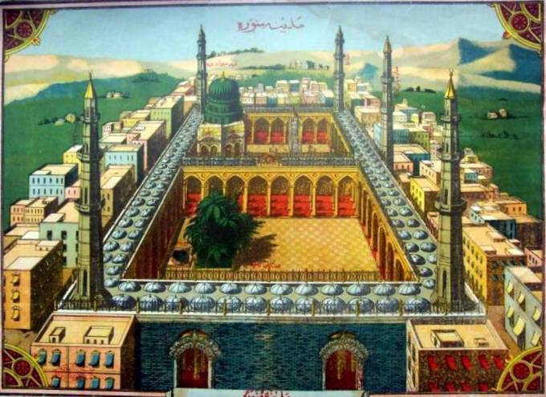
Medina: Old depiction of Medina during Ottoman times.

Culture and Religion in Pre-Islamic Arabia
The nomadic tribes of pre-Islamic Arabia primarily practiced polytheism, although some tribes converted to Judaism and Christianity.

LEARNING OBJECTIVES
Explain the significance of polytheism and monotheism in pre-Islamic Arabia

KEY TAKEAWAYS

Key Points
- Before the rise of the monotheistic religions of Judaism, Christianity, and Islam, most Bedouin tribes practiced polytheism in the form of animism and idolatry.
- Three of the ruling tribes of Yathrib (Medina) were Jewish, one of the oldest monotheistic religions.
- Christianity spread to Arabia after Constantinople conquered Byzantium in 324 CE, and it was adopted by several Bedouin tribes.
- Poetry was a large part of tribal culture and communication, and it was often used as propaganda against other tribes.

Key Terms
- polytheism: The worship of or belief in multiple deities usually assembled into a pantheon of gods and goddesses, along with their own religions and rituals.
- Ka’aba: A building at the center of Islam’s most sacred mosque, Al-Masjid al-Haram, in Mecca, al-Hejaz, Saudi Arabia. It is the most sacred Muslim site in the world.
- monotheism: The belief in the existence of a single god.
- idolatry: The worship of an idol or a physical object, such as a cult image, as a god.
- animism: The worldview that non-human entities (animals, plants, and inanimate objects or phenomena) possess a spiritual essence; often practiced by tribal groups before organized religion.

Overview
Religion in pre-Islamic Arabia was a mix of polytheism, Christianity, Judaism, and Iranian religions. Arab polytheism, the dominant belief system, was based on the belief in deities and other supernatural beings such as djinn. Gods and goddesses were worshipped at local shrines, such as the Kaaba in Mecca. Some scholars postulate that Allah may have been one of the gods of the Meccan religion to whom the shrine was dedicated, although it seems he had little relevance in the religion. Many of the physical descriptions of the pre-Islamic gods are traced to idols, especially near the Kaaba, which is believed to have contained up to 360 of them.
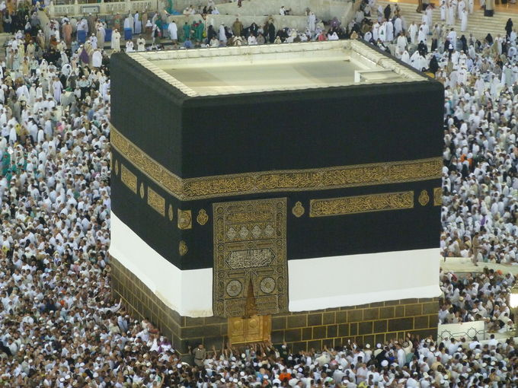
The Kaaba: The Kaaba is a cube-shaped building in Mecca held to be sacred both by Muslims and pre-Islamic polytheistic tribes.
Other religions were represented to varying, lesser degrees. The influence of the adjacent Roman, Axumite, and Sasanian empires resulted in Christian communities in the northwest, northeast, and south of Arabia. Christianity made a lesser impact, but secured some conversions in the remainder of the peninsula. With the exception of Nestorianism in the northeast and the Persian Gulf, the dominant form of Christianity was Monophysitism. The Arabian peninsula had been subject to Jewish migration since Roman times, which had resulted in a diaspora community supplemented by local converts. Additionally, the influence of the Sasanian Empire resulted in the presence Iranian religions. Zoroastrianism existed in the east and south, and there is evidence of Manichaeism or possibly Mazdakism being practiced in Mecca.

Polytheism in Pre-Islamic Arabia
Before the rise of Islam, most Bedouin tribes practiced polytheism, most often in the form of animism. Animists believe that non-human entities (animals, plants, and inanimate objects or phenomena) possess a spiritual essence. Totemism and idolatry, or worship of totems or idols representing natural phenomena, were also common religious practices in the pre-Islamic world. Idols were housed in the Kaaba, an ancient sanctuary in the city of Mecca. The site housed about 360 idols and attracted worshippers from all over Arabia. According to the holy Muslim text the Quran, Ibrahim, together with his son Ishmael, raised the foundations of a house and began work on the Kaaba around 2130 BCE.
The chief god in pre-Islamic Arabia was Hubal, the Syrian god of the moon. The three daughters of Hubal were the chief goddesses of Meccan Arabian mythology: Allāt, Al-‘Uzzá, and Manāt. Allāt was the goddess associated with the underworld. Al-‘Uzzá, “The Mightiest One” or “The Strong,” was a fertility goddess, and she was called upon for protection and victory before war. Manāt was the goddess of fate; the Book of Idols describes her as the most ancient of all these idols. The Book of Idols describes gods and rites of Arabian religion, but criticizes the idolatry of pre-Islamic religion.
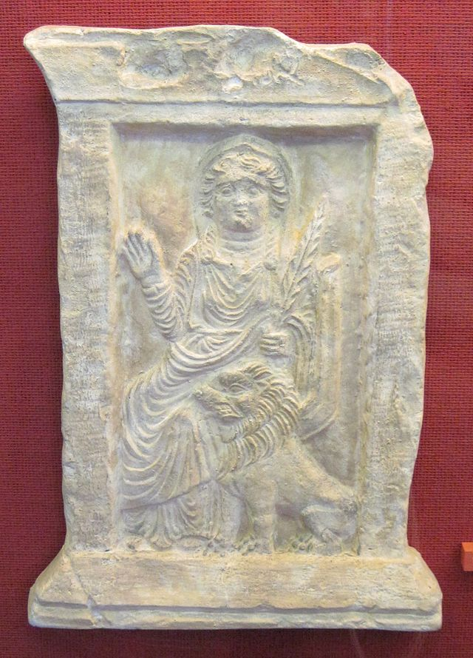
Relief of the goddess Allāt, one of the three patron gods of the city of Mecca: Before the rise of the monotheistic religions of Judaism, Christianity, and Islam, most Bedouin tribes practiced polytheism in the form of animism and idolatry.

Monotheism in Pre-Islamic Arabia

Judaism
The most well-known monotheists were the Hebrews, although the Persians and the Medes had also developed monotheism. Judaism is one of the oldest monotheistic religions.
A thriving community of Jewish tribes existed in pre-Islamic Arabia and included both sedentary and nomadic communities. Jews migrated into Arabia starting Roman times. Arabian Jews spoke Arabic as well as Hebrew and Aramaic and had contact with Jewish religious centers in Babylonia and Palestine. The Yemeni Himyarites converted to Judaism in the 4th century, and some of the Kindah, a tribe in central Arabia who were the Himyarites’ vassals, were also converted in the 4th/5th century. There is evidence that Jewish converts in the Hejaz were regarded as Jews by other Jews and non-Jews alike, and sought advice from Babylonian rabbis on matters of attire and kosher food. In at least one case, it is known that an Arab tribe agreed to adopt Judaism as a condition for settling in a town dominated by Jewish inhabitants. Some Arab women in Yathrib/Medina are said to have vowed to make their child a Jew if the child survived, since they considered the Jews to be people “of knowledge and the book.” Historian Philip Hitti infers from proper names and agricultural vocabulary that the Jewish tribes of Yathrib consisted mostly of Judaized clans of Arabian and Aramaean origin.

Christianity
After Constantine conquered Byzantium in 324 CE, Christianity spread to Arabia. The principal tribes that embraced Christianity were the Himyar, Ghassan, Rabi’a, Tagh’ab, Bahra, and Tunukh, parts of the Tay and Khud’a, the inhabitants of Najran, and the Arabs of Hira. Traditionally, both Jews and Christians believe in the God of Abraham, Isaac and Jacob, for Jews the God of the Tanakh, for Christians the God of the Old Testament, the creator of the universe. Both religions reject the view that God is entirely transcendent, and thus separate from the world, as the pre-Christian Greek Unknown God. Both religions also reject atheism on one hand and polytheism on the other.
The main areas of Christian influence in Arabia were on the northeastern and northwestern borders and in what was to become Yemen in the south. The northwest was under the influence of Christian missionary activity from the Roman Empire, where the Ghassanids, residents of a client kingdom of the Romans, were converted to Christianity. In the south, particularly at Najran, a center of Christianity developed as a result of the influence of the Christian kingdom of Axum based on the other side of the Red Sea in Ethiopia. Both the Ghassanids and the Christians in the south adopted Monophysitism. The spread of Christianity was halted in 622 CE by the rise of Islam, though the city of Mecca provided a central location for an intermingling of the two cultures. For example, in addition to the animistic idols, the pre-Islamic Kaaba housed statues of Jesus and his holy mother, Mary.

Nomadic Culture and Poetry
Like later cultures in the region, the Bedouin tribes placed heavy importance on poetry and oral tradition as a means of communication. Poetry was used to communicate within the community and sometimes promoted tribal propaganda. Tribes constructed verses against their enemies, often discrediting their people or fighting abilities. Poets maintained sacred places in their tribes and communities because they were thought to be divinely inspirited. Poets often wrote in classical Arabic, which differed from the common tribal dialect. Poetry was also a form of entertainment, as many poets constructed prose about the nature and beauty surrounding their nomadic lives.

